Samiksha Mailarpwar

Alex Lambrecht

Deliverable #3

*A Real-Time Mobile Survey of Alcohol Use and Sexual Consent in Social Research Participants*

**Project Overview:**

The purpose of this capstone is to create a mobile application that can track, in real-time, data from participants about their drinking habits, and to provide a web-facing tool for social science researchers to explore the raw data and provide preliminary analyses. The app allows participants to report their drinking on location, as well as subsequent surveys about perceived levels of drinking, and store this data in a secure database. The web-facing element will assist researchers from the School of Public Health and Social Justice to view both individual and agglomerated data slices in order to perform the preliminary analyses.

**Background:**

The motivation behind this project is to improve response accuracy in social research participants. Current research methods rely on online or paper surveys (i.e. Qualtrics, Survey Monkey, etc.) to collect data in order to analyze alcohol consumption and sexual consent. Participants are asked to complete the surveys post-drinking episodes, mixing in a higher degree of human error. The mobile application BoozyMeter will serve to replace the older methods by providing an interface for real-time data collection.

**BoozyMeter Functionality:**

Prior to beginning a drinking episode, the participant must press Start in the mobile application. Every time the participant takes a drink, they must log it into the application and answer four easy questions (type, size, with whom, and where). The answers are logged into the database. The participant can keep logging their drinks, but the application also runs on a timer. If no user input for thirty minutes, the app sends a notification reminding the user to log their activity. If no user input for two hours, the app will stop logging data and revert back to the home screen. Google’s location services run in a service (in the background) and log location every ten minutes as long as the user is actively logging their drinks. At 8:00 AM the following morning, the user will receive a notification to fill out a Morning Questionnaire, which contains the sexual consent questions and a morning report summary of their previous night.

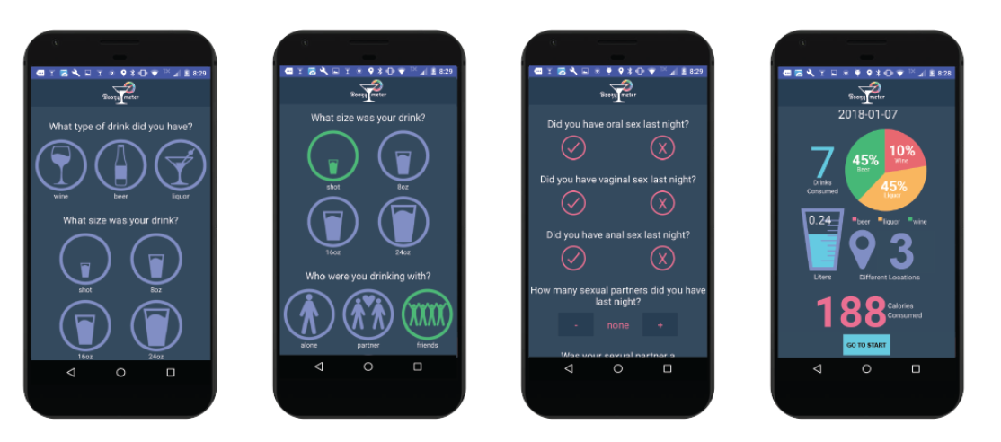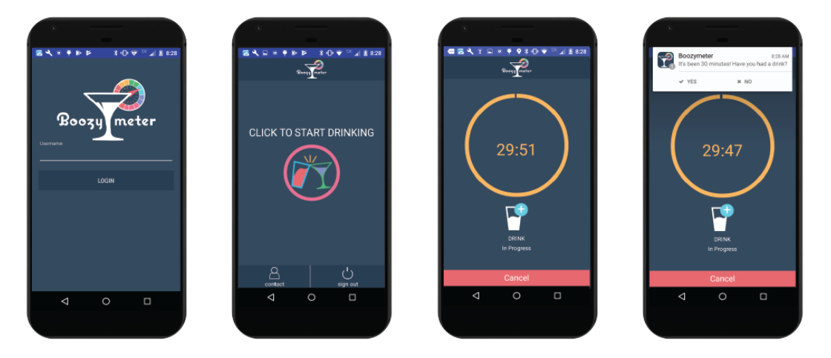

**BoozyAnalytics Functionality:**

The second part of the capstone project includes a web-facing portal and an Excel Analytics Workbook. The portal only allows authorized users (identified as Admins in the database) access to the data.  The BoozyAnalytics web-portal is a space for researchers to go and view the data that has been collected from BoozyMeter.  It gives the researcher the ability to view and search the raw data table as well as export the data to an excel worksheet.  The web-portal also gives the researchers user management capabilities.  From the portal, admins are able to add and delete users, therefore taking away log-in capabilities for participants to access the app (note: deleting a user from BoozyMeter authentication does not remove any logged data from the database).  The admins are also able to give participants control or experimental conditions, which would be reflected in the functionality of the app. Along with participant management, admins are also able to add and delete other admins from the BoozyAnalytics system. The final functionality of the web-portal provides admins with the ability to view a live dashboard of participants who are actively using the app as well as view individual participant reports that give a brief statistical summary of the users behaviors.

BoozyAnalytics also provides researchers with a pre-built Excel Analytics Workbook.  This workbook allows the researcher to import both the raw data collected from the users via BoozyMeter as well as the demographic information collected separately.  Once the data is imported, the Analytics Workbook will merge data based on common usernames and provide preliminary filtering and statistical analysis for the researcher to begin their own analysis.  This will give the researcher a fast way to view different filtered versions of the data while also an easy to export combined data table that can be used in the analytics software of their choice.

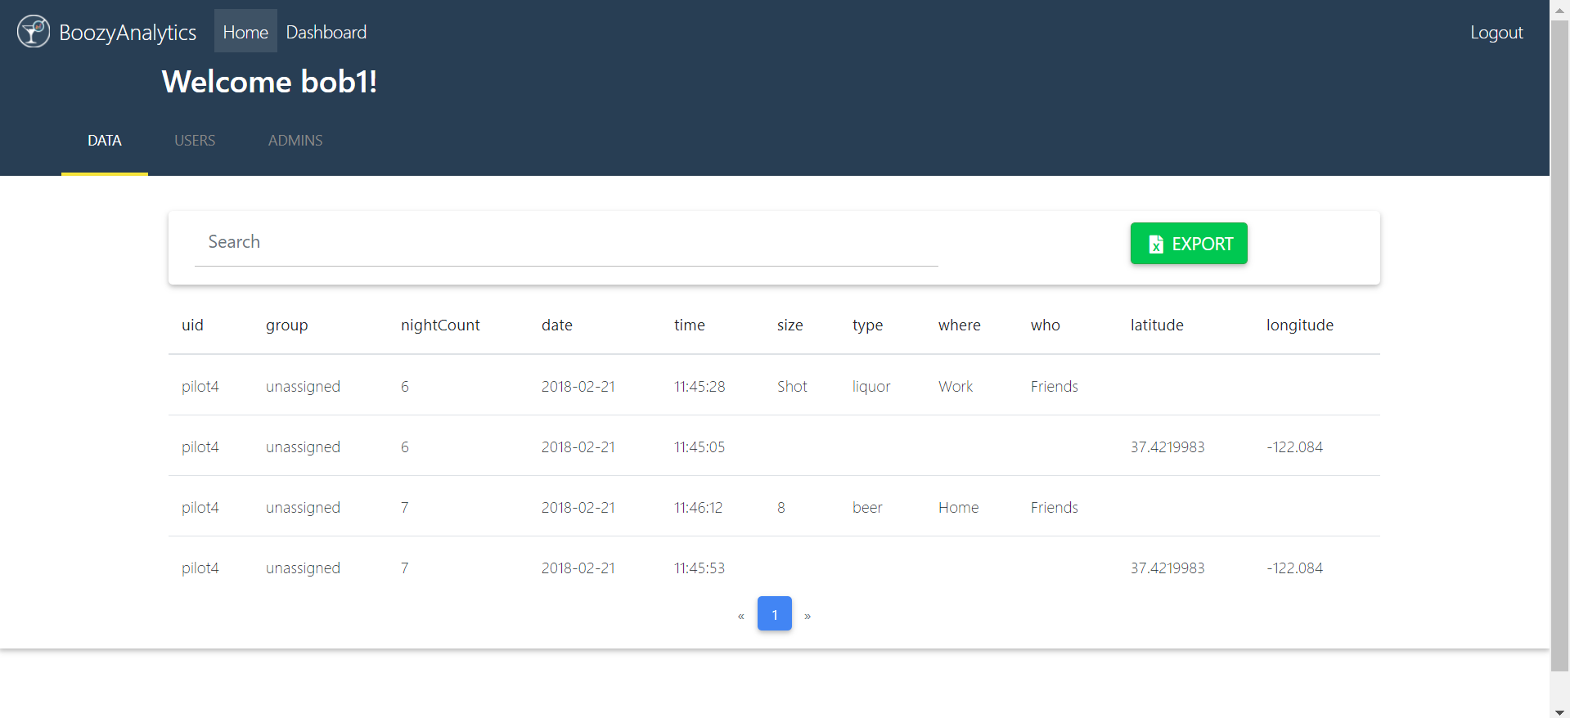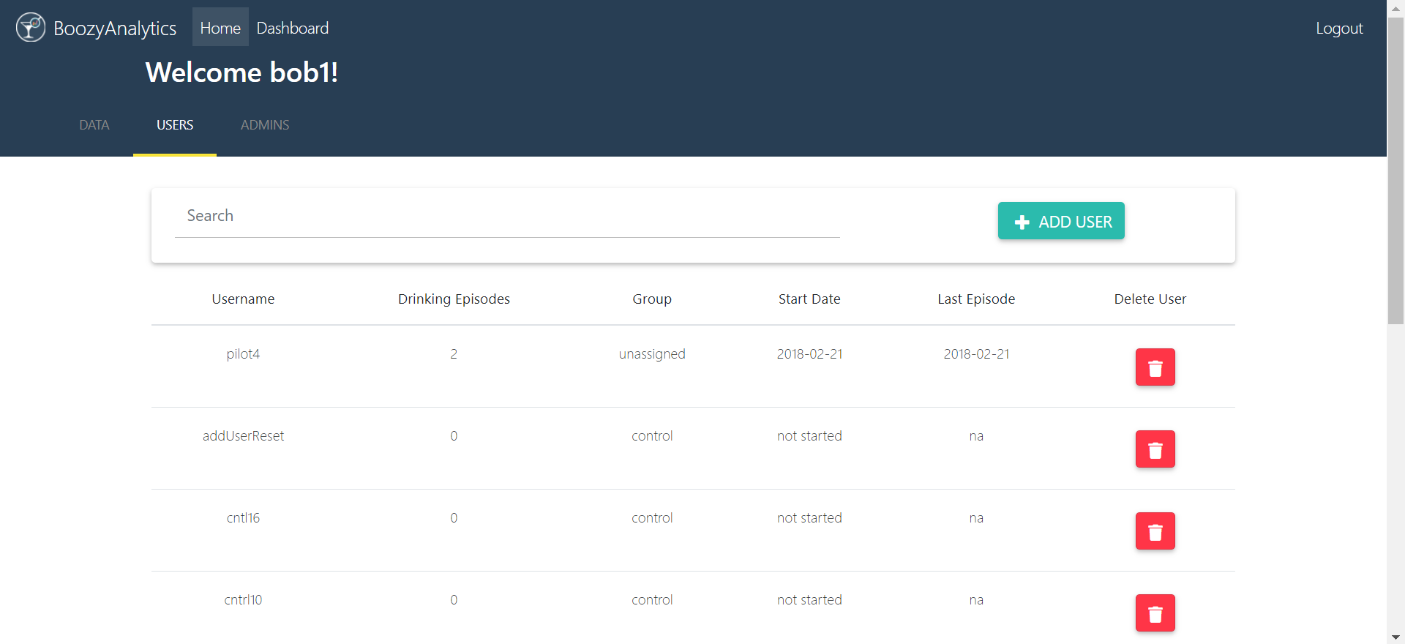

**Requirements:**

|  |  |  |
| --- | --- | --- |
| **Requirement** | **Priority** | **Description** |
| REQ 1 | Completed | Reading Data From Firebase |
| REQ 2 | Completed | Admin Authentication |
| REQ 3 | Completed | Exporting Raw Data |
| REQ 4 | Completed | Add/Delete Users to Database with control vs experimental labels |
| REQ 5 | Completed | Filter Data into tabular format |
| REQ 6 | Completed | Add/Delete Admins |
| REQ 7 | Completed | Create Excel Analytics Workbook that allows data import via picker |
| REQ 8 | Should Have | Excel Basic Analytics |
| REQ 9 | Nice to Have | Live User Data Dashboard |
| REQ 10 | Nice to Have | Individual Participant Pages |
| REQ 11 | Should Have | App Control/Experimental Functionality |
| REQ 12 | Should Have | User Feedback Changes For App (Honors Capstone) |

**Backend/Database:**

The data for BoozyAnalytics and BoozyMeter is stored in Google’s Firebase, a secure cloud-storage system.  Firebase allows for easy authentication on both the web and app facing platforms.  It is also helpful for displaying live data updates to the researcher because it has the ability to load data in realtime. A good amount of time was spent on structuring the database in order to distinguish between Admins and Users, and further into Control and Experimental Users. The data in the database is stored in a JSON tree format, which had to be parsed in order to export data into the Android application or the website.

**Timeline:**

**Deliverable #4:** Final product with website, mobile application, and excel query sheet

* Website has a realtime dashboard that updates and displays certain information
* Website has individual participant pages that give an overview of the participant’s data
* Push website on Hopper Apache server
* App distinguishes between control and experimental users
* Build Excel spreadsheet using VBA